Online Shopping Cart

Introduction:

In today’s fast changing business environment, it’s extremely important to be able to respond to customer need in most effective manner. With help of data structure’s linked list concept a user friendly GUI can be made for the open market.

Advantages:

* As we use linked list in this program which makes it storage efficient.
* Nodes can be accessed with help of traversing.
* Adding or deleting of element is easy.

Disadvantages:

* Singly linked require more pointers.
* Different amount of time is required to access each element.
* We cannot traverse it from last

How data structure is used in project implementation:

In this project we used enqueue function to insert items in shopping list as well as to add item in customer’s cart. Deque function is used to remove item from shopping cart as well as to remove any product if required by admin access. Display function is used to print the cash memo and to display the cart and shopping item list. The admin page is locked by a password 273133. Admin can insert or remove any item from list or can change cost of any item.

Conclusion:

Hence with help of data structure we created a user friendly GUI with help of concept of ‘Singly Linked List ’.

Program:

#include <stdio.h>

#include <stdlib.h>

#include <string.h>

#define password 273133

struct node

{

char name[20];

int price;

struct node *link;

}*list=NULL,*cart=NULL;

void insertEnd(int x,char y[20],struct node *z)

{

struct node *n,*p;

n=(struct node*)malloc(sizeof(struct node));

strcpy(n->name,y);

n->price=x;

n->link=NULL;

if(z==NULL)

{

if(z==list)

{

list=n;

}

else

{

cart=n;

}

}

else

{

p=z;

while(p->link != NULL)

{

p=p->link;

}

p->link=n;

}

}

void deleteSpecific(char key[20],struct node *x)

{

int n;

struct node *p,*q;

if(x==list)

{

p=list;

q=list;

}

else

{

p=cart;

q=cart;

}

if(x==NULL)

{

printf("\nLL is empty");

return;

}

else

{

if(p->link==NULL)

{

if((strcmp(key,p->name))!=0)

{

nextline(1);

space(20);

printf("Key not found!");

return;

}

else

{

if(x==list)

{

list=NULL;

}

else

{

cart=NULL;

}

printf("\nItem Deleted");

return;

}

}

else

{

while(p!= NULL)

{

if((strcmp(p->name,key))==0)

{

if(p==x)

{

if(x==list)

{

list=p->link;

}

else

{

cart=p->link;

}

return;

}

q->link=p->link;

return;

}

q=p;

p=p->link;

}

if(p==NULL)

{

printf("\nKey not found");

}

}

}

}

void insert_list()

{

char name[20];

strcpy(name,"Lays_chips");

insertEnd(20,name,list);

strcpy(name,"Pepsi");

insertEnd(45,name,list);

strcpy(name,"Santoor_soap");

insertEnd(30,name,list);

strcpy(name,"Dettol_handwash");

insertEnd(50,name,list);

strcpy(name,"Cheese");

insertEnd(100,name,list);

strcpy(name,"T-shirt");

insertEnd(500,name,list);

strcpy(name,"Watch");

insertEnd(1000,name,list);

strcpy(name,"frozen food");

insertEnd(200,name,list);

strcpy(name,"Ice cream");

insertEnd(100,name,list);

strcpy(name,"pendrive");

insertEnd(500,name,list);

}

int count(struct node *p)

{

int i;

if(p==NULL)

return(0);

else

{

for(i=0;p!=NULL;i++)

{

p=p->link;

}

return(i);

}

}

void deleteid(int id,struct node *n)

{

struct node *p=n;

int i;

for(i=0;i<id;i++)

{

p=p->link;

if(p == NULL)

{

printf("\n\n\n\n\n\n ID not found");

return;

}

}

deleteSpecific(p->name,n);

printf("\n\n\n\n\n\n Item deleted!");

}

void printLine()

{

int n;

nextline(1);

space(40);

for(n=0;n<=38;n++)

{

if(n == 0 || n == 6 || n == 27 || n == 38)

{

printf("+");

}

else

printf("-");

}

}

void displayList(struct node *l)

{

int i=0,j,k;

system("cls");

nextline(2);

space(55);

printf("VIVA SUPERMARKET");

nextline(1);

if(l==NULL)

{

nextline(4);space(40);

printf("EMPTY");

printf("\n\n\n\n\n\n\n\n\n\n Enter any key to return");

}

else

{

printLine();

nextline(1);

space(40);

printf("| ID | Name | Price |");

printLine();

while(l!=NULL)

{

nextline(1);

space(40);

printf("|%3d | %s",i,l->name);

space(18-(strlen(l->name)));

printf("| %6d |",l->price);

l=l->link;

i++;

}

printLine();

}

}

void displayCart(struct node *l)

{

int i=0,j;

float k=0;

system("cls");

nextline(2);

space(53);

printf("VIVA SUPERMARKET");

nextline(1);

if(l==NULL)

{

nextline(5);

space(55);

printf("CART IS EMPTY!");

return;

}

else

{

printLine();

nextline(1);

space(40);

printf("| ID | Name | Price |");

printLine();

while(l!=NULL)

{

nextline(1);

space(40);

printf("|%3d | %s",i,l->name);

space(18-(strlen(l->name)));

printf("| %6d |",l->price);

k=k+l->price;

l=l->link;

i++;

}

printLine();

nextline(1);

space(40);

printf("| TOTAL | %7.2f |",k);

printLine();

}

}

void displayCheckout(struct node *l)

{

int i=0,j;

float k=0,gst;

system("cls");

nextline(2);

space(52);

printf("VIVA SUPERMARKET");

nextline(1);

if(l==NULL)

{

nextline(5);

space(55);

printf("CART IS EMPTY!");

return;

}

else

{

printLine();

nextline(1);

space(40);

printf("| ID | Name | Price |");

printLine();

while(l!=NULL)

{

nextline(1);

space(40);

printf("|%3d | %s",i,l->name);

space(18-(strlen(l->name)));

printf("| %6d |",l->price);

k=k+l->price;

l=l->link;

i++;

}

printLine();

nextline(1);

space(40);

printf("| Sub Total | %7.2f |",k);

printLine();

gst=(k*2.5)/100;

nextline(1);

space(40);

printf("| CGST 2.5%%| %7.2f |",gst);

nextline(1);

space(40);

printf("| SGST 2.5%%| %7.2f |",gst);

printLine();

nextline(1);

space(40);

printf("| TOTAL | %7.2f |",k+(2*gst));

printLine();

}

}

void admin_menu()

{

int i,id,ch,pric;

char name[20],condition;

do{

system("cls");

printf("\n\n\n\n\n\n ");

for(i=0;i<100;i++)

{

printf("=");

}

printf("\n\n\n\n 1--->View Products \n\n 2--->Add Product \n\n 3--->Remove Product \n\n 4--->Logout");

printf("\n\n\n\n ");

for(i=0;i<100;i++)

{

printf("=");

}

printf("\n Enter your choice :");

scanf("%d",&ch);

switch(ch)

{

case 1 : displayList(list);

getch();

break;

case 2 : do{

system("cls");

printf("\n\n\n\n\n\n\n\n\n\n Name:");

scanf("%s",name);

printf("\n\n\n\n Price:");

scanf("%d",&pric);

insertEnd(pric,name,list);

printf("\n\n\n Succesfully inserted");

printf("\n\n\n\n\n Do you want to Add More?[y/n]:");

condition = getch();

}while(condition!= 'n');

break;

case 3 : system("cls");

displayList(list);

printf("\n\n\n\n Enter Item ID:");

scanf("%d",&id);

deleteid(id,list);

nextline(5);

space(15);

getch();

break;

}

}while(ch<4);

}

void nextline(int x)

{

int i;

for(i=0 ; i<x ; i++)

{

printf("\n");

}

}

void space(int x)

{

int i;

for(i = 0 ; i < x ; i++)

printf(" ");

}

void login()

{

int pass;

system("cls");

printf("\n\n\n\n\n\n\n\n\n\n\n PASSWORD:");

scanf("%d",&pass);

if(pass== password)

{

admin_menu();

}

else

{

printf("\n\n\n\n\n\n\n INVALID PASSWORD, PLEASE TRY AGAIN");

getch();

}

}

void insertProduct(int key)

{

int i,pric;

char name[20];

struct node *p=list;

for(i=0;i<key;i++)

{

p=p->link;

if(p == NULL)

{

printf("\n\n\n\n\n\n ID not found");

return;

}

}

pric=p->price;

strcpy(name,p->name);

insertEnd(pric,name,cart);

}

void Add_cart()

{

int product;

char ch;

do{

system("cls");

displayList(list);

printf("\n Enter the product ID:");

scanf("%d",&product);

insertProduct(product);

printf("\n Do you want to add another item to cart[y/n]");

ch=getch();

}while(ch != 'n');

}

void checkout()

{

system("cls");

displayCheckout(cart);

printf("\n\n\n\n THANK YOU FOR SHOPPING WITH OUR STORE");

getch();

main_menu();

}

void cust_login()

{

int i,id,ch,c;

char name[20];

do{

system("cls");

printf("\n\n\n\n\n\n ");

for(i=0;i<100;i++)

{

printf("=");

}

printf("\n\n\n\n 1--->View Products \n\n 2--->View Cart(%d) \n\n 3--->Logout",count(cart));

printf("\n\n\n\n ");

for(i=0;i<100;i++)

{

printf("=");

}

printf("\n Enter your choice :");

scanf("%d",&ch);

switch(ch)

{

case 1 : displayList(list);

printf("\n\n\n\n 1--->Add to cart \n\n 2--->back");

scanf("%d",&c);

if(c== 1)

Add_cart();

break;

case 2 : displayCart(cart);

printf("\n\n\n\n 1--->Checkout \n\n 2--->delete Item \n\n 3-->back");

scanf("%d",&c);

if(c== 1)

checkout();

{

system("cls");

displayList(cart);

printf("\n\n\n\n Enter Item ID:");

scanf("%d",&id);

deleteid(id,cart);

nextline(5);

space(15);

break;

}

break;

}

}while(ch<3);

}

void main_menu()

{

int i,ch;

do{

system("cls");

printf("\n\n\n\t\t\t\t\t\t VIVA SUPERMARKET");

printf("\n\n\n\n ");

for(i=0;i<100;i++)

{

printf("=");

}

printf("\n\n\n\n 1--->Admin login \n\n 2--->Customer \n\n 3--->Exit");

printf("\n\n\n\n ");

for(i=0;i<100;i++)

{

printf("=");

}

printf("\n Enter your choice :");

scanf("%d",&ch);

switch(ch)

{

case 1 : login();

break;

case 2 : cust_login();

break;

case 3 : exit(0);

break;

}

}while(ch<3);

}

int main()

{

system("color f0");

insert_list();

main_menu();

return 0;

}

Screenshots:

Main menu -

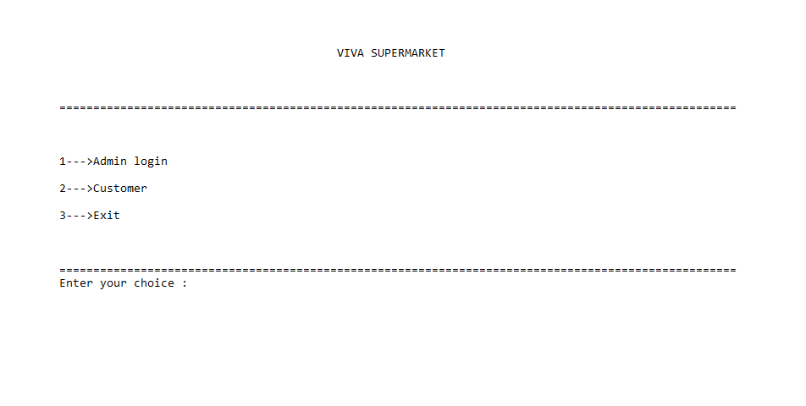

Admin page-

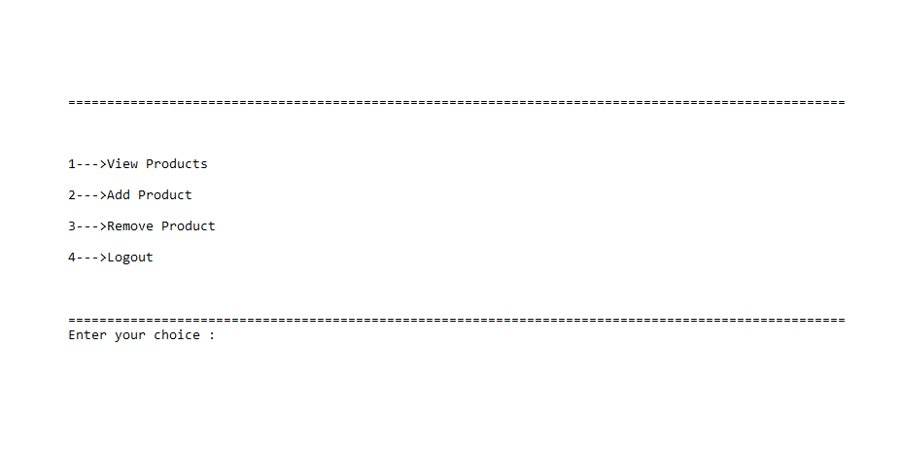

Product list- Insertion of product-

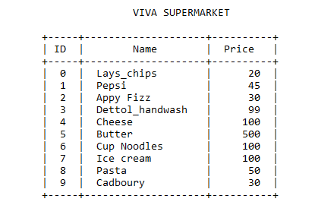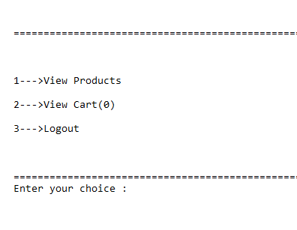

Deletion of product- Customer mrnu-

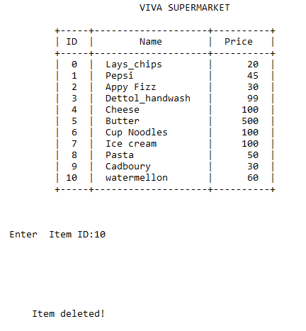

Customer list- Customer add cart-

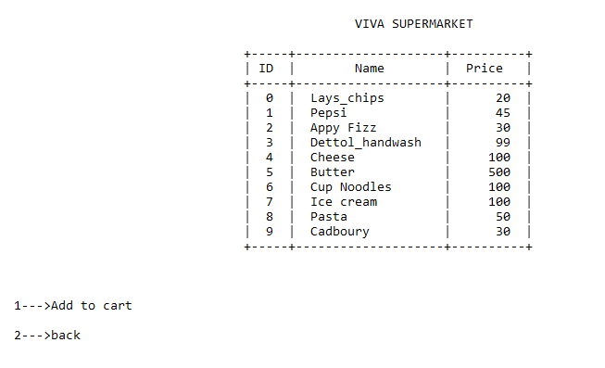 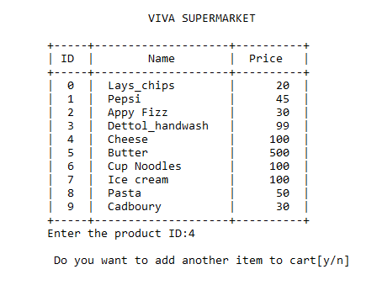

Customer cart- Customer bill

